News Release  - August 15, 2019 | Naples, FL | 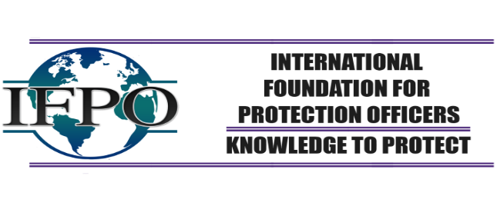

IFPO Career Center Provides Pathway to Security Sucess
The security industry has created tremendous career opportunities over the past several decades and will continue to do so, with major growth drivers such as cybersecurity, severer weather events and mass violence.
Homeland Security. Retail Loss Prevention. Security Services. VIP protection. Private and Corporate Investigation. Systems Design and Integration. Armored Cars. Security Consulting. Special Events Security. All of these are components of the diverse and complex security industry; an industry that protects everything from critical infrastructure to homes, workplaces, schools and healthcare facilities.
Obtaining reliable and easily-digested information about security careers has been difficult until now.
The new Career Center, launched by the International Foundation for Protection Officers (IFPO), provides a snapshot of career pathways. It also gives access to additional career development options, including professional certifications, education, training and professional associations, which provide opportunities for professional development and networking.
Contact US:

The International Foundation for Protection Officers is a nonprofit educational entity dedicated to meeting the professional development needs of security personnel. It offers professional certification processes, certificate programs, an extensive menu of discounts on Foundation programs as well as those of IFPO affiliates. Membership is available for individuals and organizations.
Sandi Davies
Executive Director
1076 6th Avenue N.
Naples, FL 34102
The International Foundation for Protection Officers
239.430.0534
sandidavies@ifpo.org
www.ifpo.org

_________________________________________________________

THE INTERNATIONAL FOUNDATION FOR PROTECTION OFFICERS:
Mission Statement: The International Foundation for Protection Officer is committed to the support and professional development of protection officers. Through advocacy; promoting training standards; and providing accessible training, education and certification opportunities; we seek to enhance the professional standing of protection officers, as well as increase and diversify the value of the vital services they provide.

