Active Shooter
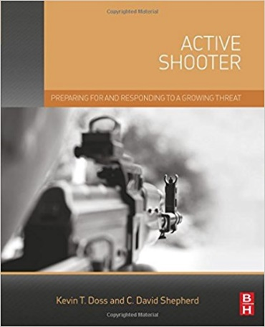
Authors: Kevin T. Doss and C. David Shepard
ISBN: 978-0-12-802784-4
ISBN-13: 978-0123850577
Publisher: Elsevier
Publish Date: 2015
Page Count: 291

According to Pinkerton/Securitas―the leading provider of risk management services in the world―workplace violence is second only to cybersecurity as the top threat faced by organizations today. Incidents involving active shooters in the workplace are on the rise and becoming more violent and deadly. Active Shooter provides the tools necessary to identify potential violent individuals, along with the options and responses needed to save lives, reduce corporate liability, and recover from an active shooter event should it happen.
Active Shooter begins with a brief history of active shooters and how they have changed over time. It shows why many perpetrators initiate attacks, what they often are thinking, and some of the indicators that could have been identified prior to the attack. The book shows how to develop an active shooter program in an organization, walking readers through the entire process including training exercises to test the efficiency of the program. With the uniquely private security perspective,
This book is one of several in the market but it’s a cut above the others in that it addresses a large degree of issues and possible causes to Active Shooters. You will use this book as a major reference to your collection.
Review by ASIS Dynamics:
"Anyone concerned with protecting soft targets can learn something from this book . . . this is one of the most comprehensive and readable books on this important subject. Readers will no doubt look forward to more from these authors."
Review by the Journal of Counterterrorism and Homeland Security International:
"...a comprehensive and detailed examination of the measures required to prevent active shooter events, ranging from preparing for, responding to, and recovering from such incidents."
Review by Eugene Ferraro on Amazon.com:
Excellent work. Comprehensive and easy to read. Informative and logical. Best I have read on topic to date.

Based on our opinions and also the other reviews, we give Active Shooter FIVE Stars.
Review by: Lawrence J. Fennelly, CPOI, CSSI and Marianna A. Perry, M.S., CPP, CPOI

