Risk Analysis and Security Countermeasure Selection, Second Edition
2016 ASIS International Book of the Year
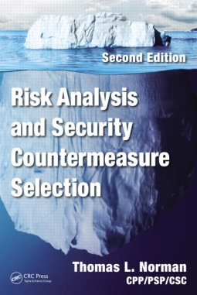
Author: Thomas L. Norman, CPP/PSP/CSC
ISBN: 9781482244199
Publisher: CRC Press
Published Date: July 1, 2015
Page Count: 483

“Let me just state that a security technician is a security system designer, in the same way that an automobile mechanic is an automobile designer.”
Thomas L. Norman, 2016

Risk Analysis and Security Countermeasure Selection begins by discussing both risk analysis theory and practice followed by threat analysis and how to assess vulnerability. The author explains the five core principles of the risk analysis lifecycle: Determining Assets, Threats, Vulnerabilities, Risks, and Countermeasures. Commonly used Department of Homeland Security (DHS)-approved risk analysis methods are discussed along with a risk analysis methodology that can conform to DHS standards and can also be applied to public and private industries. The author discusses in detail the process to use when selecting various countermeasures as well as budgeting for them. Metrics are used to measure cost-effectiveness when discussing various countermeasures and case studies are used to illustrate their strengths. This book is a comprehensive reference manual and a “must have” for any security professional.

Based on our opinions and also other reviews, we give Risk Analysis and Security Countermeasure Selection FIVE stars.

Review from Amazon.com:
"This book, like its predecessor, will become a desk reference used by security professionals everywhere. Like any great reference work, it will be dog-eared, feathered with Post-It Notes, with handwriting scrawled in the margins."
Ross Johnson, CPP, 2016

Lawrence J. Fennelly CPOI, CSSM and Marianna A. Perry, M.S., CPP, CPOI

